Expert Finder App
Manual

General Information
Expert Finder is an online expert database where you can find experts. Using the search functionality, you can find experts using food-related topics such as: Topics of Expertise, Food Group, Chemical Substances or directly with an expert such as name, projects, countries, languages and organization.
The first field provides search over expert fields like first name, last name, job title, organisation, field of study, university, project name, expert role, publication title.
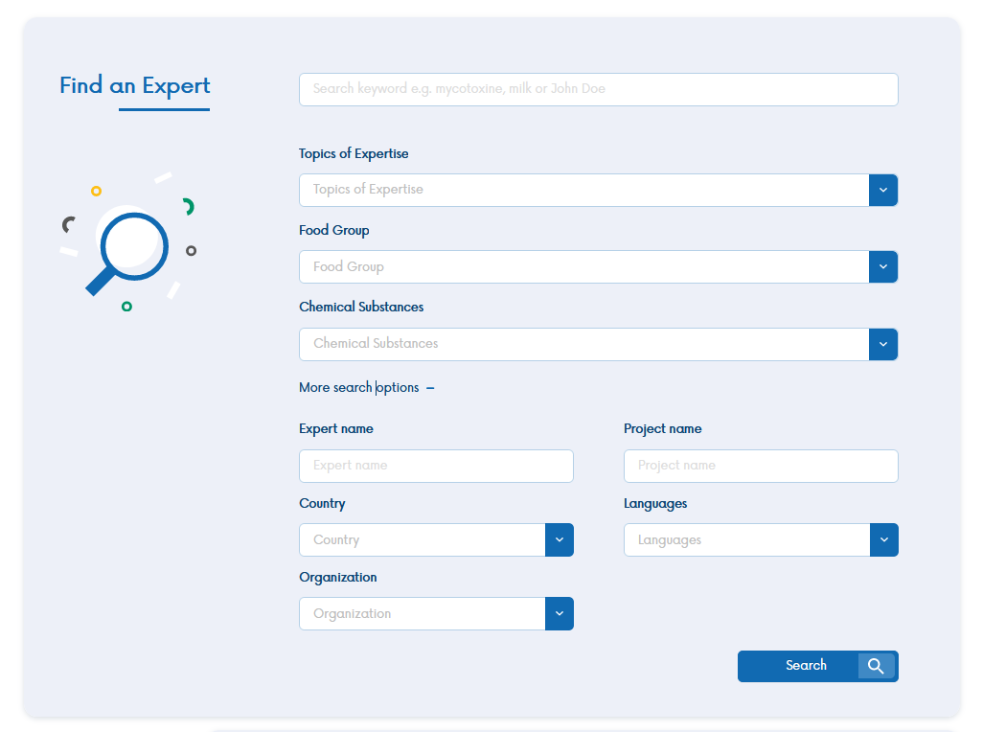
Picture 1. Expert search engine appearance
In the expert search results, you can find basic information such as first name, surname, country of origin, as well as area of expertise and profile picture.
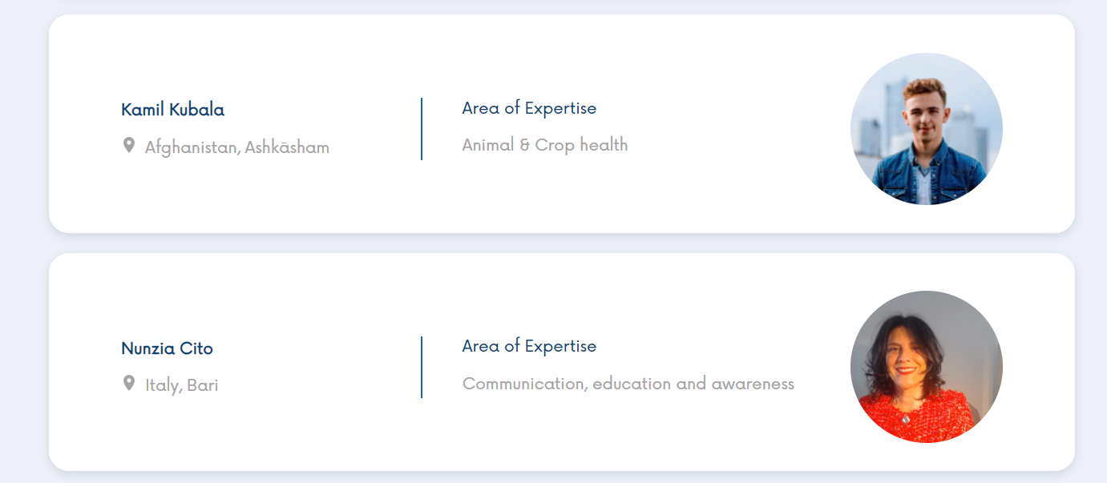
Picture 2. Sample search result

In the expert profile you can find the user's tag cloud, first name, last name, city, e- mail address and current employment.
You will also find known languages and area of expertise and the contact link provided by the expert (e.g., to the profile on LinkedIn).
Below you will find 5 tabs, the first one is a professional experience, where you can find out about the positions, company names, dates of employment and working time experience.
The next tab is Education, where you will find graduated university, field of study and degree.
The third tab contains Projects & Research, where you can find project / research name, expert role, link to project / research website and duration of the project.
In the fourth tab you will find Reports & Publications, where you will find the title, publisher, publication date, co-authors and link to publication.
In the last tab you will find the contact and more information about the expert.

Expert registration

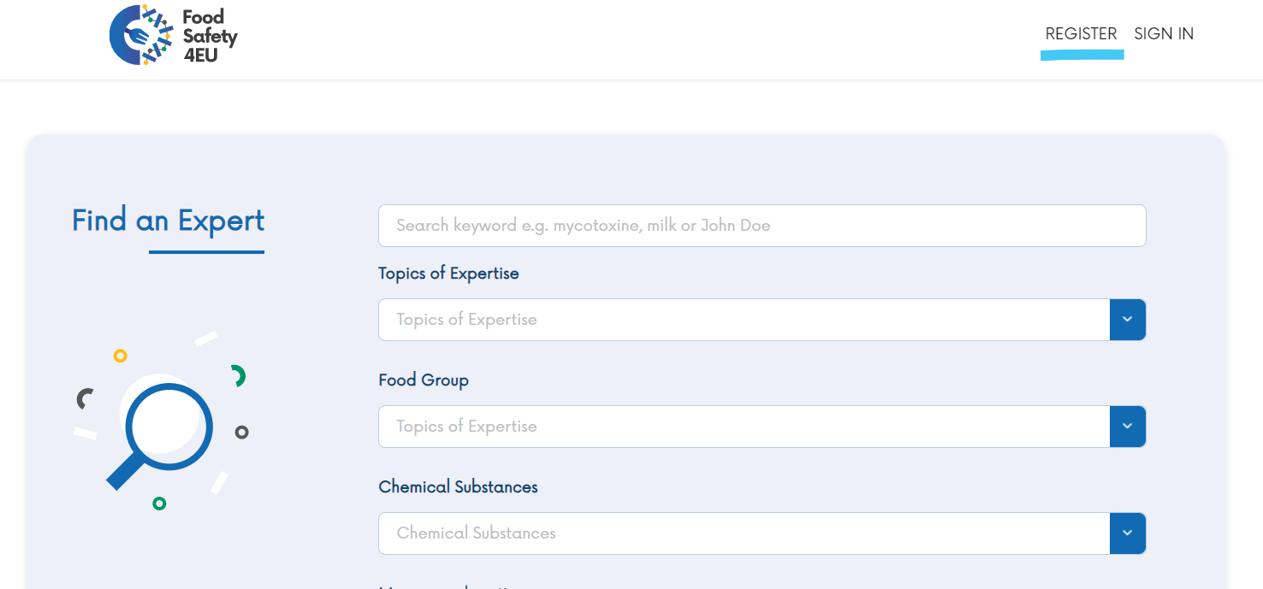
In order to register, you should select the REGISTER option in the top right corner.
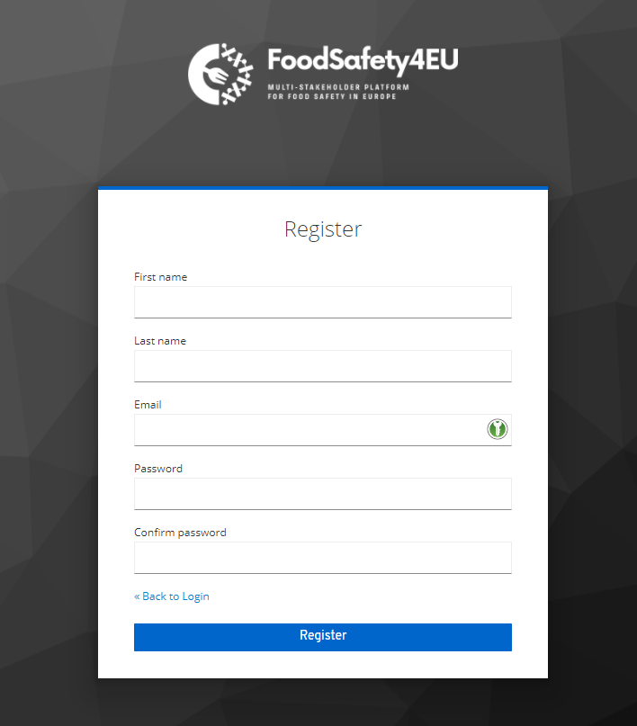

After redirecting to the registration page, you have to fill in basic information about you, e-mail address, password and confirm a password.
For security reasons, we suggest that the password consists of a minimum of 8 characters, including upper- and lower-case letters, numbers and a special character.

After creating your account, you can complete your public expert profile. To do this, select the blue button “Register as an expert”.
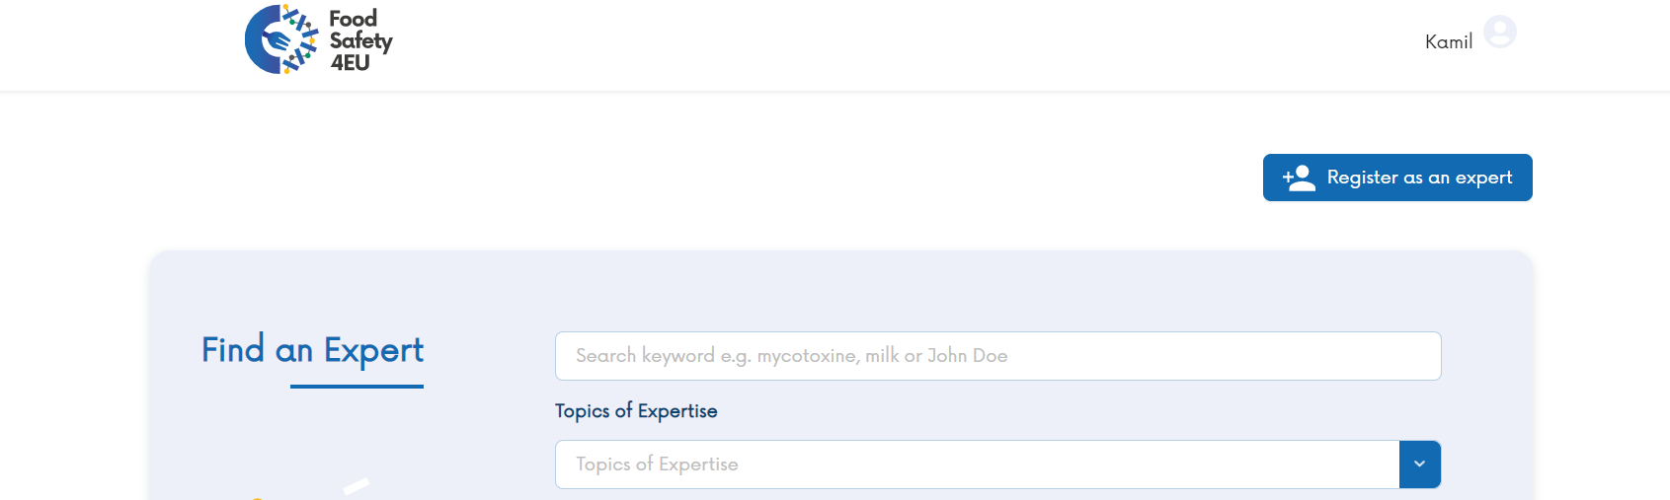
The form consists of 7 segments:
- personal data,
- education,
- professional experience,
- areas of expertise,
- projects and research,
- reports and publications,
- additional information.
The fields marked with a red star are mandatory.
It is possible to add several schools / projects / publications / work experiences by selecting the "Add another << e.g., Education >>" button. At any time, you can remove the part by selecting "remove". It is required for an expert to complete at least one school, experience and project.
You can add an avatar by uploading an image in .jpg or .png format, up to 1MB in size.
The data in the areas of expertise segment is expandable by selecting the triangle on the left of the name. You can choose more than one option.
Don’t forget to save your form, using the “Save your profile” button at the bottom of the page.
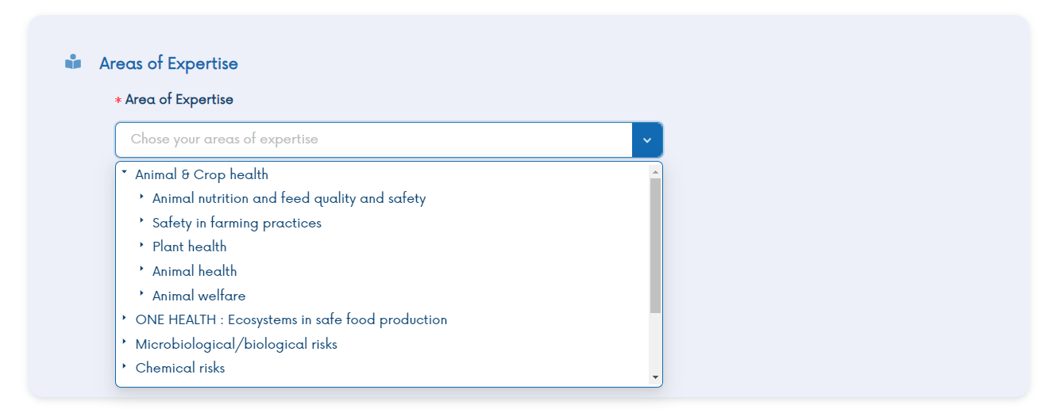

You can edit the data in the future by selecting the "Edit expert" button. It will be available instead of "Register as an expert" after completing the expert form.

We wish you a pleasant use!

